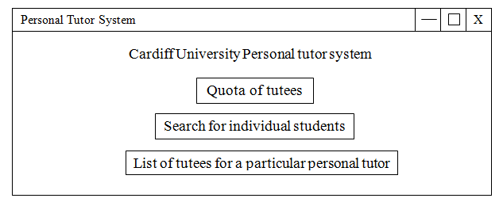

Quota of tutees test cases

Test Case Id: 1 |  | Test Purpose:  Testing if the home page opens up the quota of tutees tab.
Environment: Windows 7 , python 3.2.5, sqlite3
Preconditions: Have the Personal Tutor System Home page open
Test Case Steps:
Step No | Procedure |  |  | Response | Pass/Fail
1 | Open the Cardiff University Personal Tutor System Home page.  Print screen the outcome and place it in the comments. |  |  | A tab should pop up containing three buttons the user can click. | PASS
2 | Click on the Quota of tutees Button |  |  | This should open up the Quota of tutees tab, which contains a search bar and an enter button. | PASS
3 | Print Screen the new tab which appears and place it within the comment section
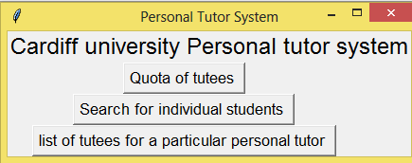
Comments:

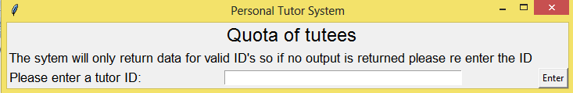

Related Tests: None
Author: Lili Rossiter |  |  | Checker: Catherine Rossiter

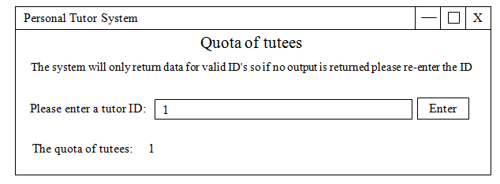

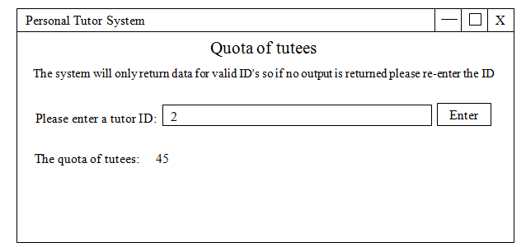

Test Case Id: 2 |  | Test Purpose:  Testing if the Quota system returns the correct number of tutees using different Tutor ID’s
Environment: Windows 7 , python 3.2.5, sqlite3
Preconditions: Have the quota of tutees tab open
Test Case Steps:
Step No | Procedure |  |  | Response | Pass/Fail
1 | Once the tutee quota Tab is open enter the number 1 in the text box. |  |  |  | PASS
2 | Click on the enter button. |  |  | The “quota of tutees “should return as 1. | PASS
3 | Print screen the Outcome and place it within the comments section
4 | Now enter the number 2 in the text box. |  |  |  | PASS
5 | Click on the enter button again. |  |  | The “quota of tutees” should change to 45. | PASS
6 | Print screen the Outcome again and place it within the comments section.
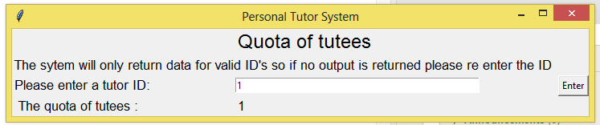
Comments:

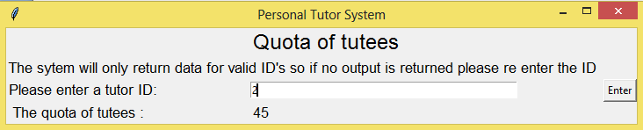

The data returned was correct
Related Tests: 1 (Testing if the main page opens up the quota of tutees tab.)
Author: Lili Rossiter |  |  | Checker: Catherine Rossiter

Test Case Id: 3 |  | Test Purpose:  Testing if the Quota system doesn’t output data when the text box is empty  Or an invalid ID is entered.
Environment: Windows 7 , python 3.2.5, sqlite3
Preconditions: Have the quota of tutees tab open
Test Case Steps:
Step No | Procedure |  |  | Response | Pass/Fail
1 | Delete any text that’s inside of the text bar (making it empty)
2 | Click on the enter button, and print screen the outcome placing it in the comment section. |  |  | No new information or data should appear and nothing should change as the entry is invalid. | PASS
5 | Next enter the id of 9000 into the text bar and click the enter button. Print screen the outcome and place it in the comment section. |  |  | Again no new information or data should appear as this entry is also invalid as there are no tutors that have this ID. | PASS
6 | Next enter the Id of 2 into the text bar and click on the enter button. Print screen the outcome and place it in the comment section. |  |  | The ID should now be excepted as valid and a quota should be returned with the value of 45 | PASS
Comments:
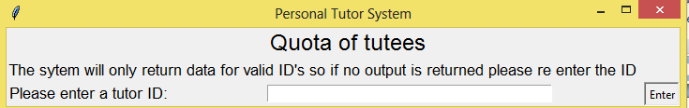

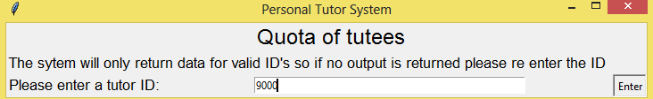

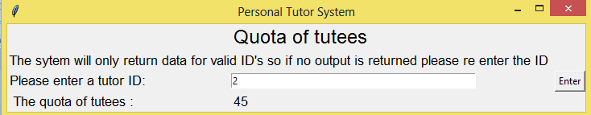

All of the predicted outcomes occurred
Related Tests: 3 (Testing if the Quota system returns the correct number of tutees using the ID of 2)
Author: Lili Rossiter |  |  | Checker: Catherine Rossiter

Search for Individual Students Test cases.

Test Case Id: 4 |  | Test Purpose: Does program return results based on Surname
Environment: Windows 7, Python 3.2.5, SQLite3
Preconditions: Window is open from launch hub
Test Case Steps:
Step No | Procedure |  |  | Response | Pass/Fail
1 | Enter Surname into appropriate field. |  |  | N/A | PASS
2 | Click ‘Search’ button |  |  | Return results in tabulated format. | PASS
Comments: Formatting leaves a lot to be desired.
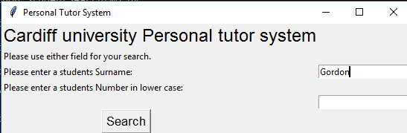
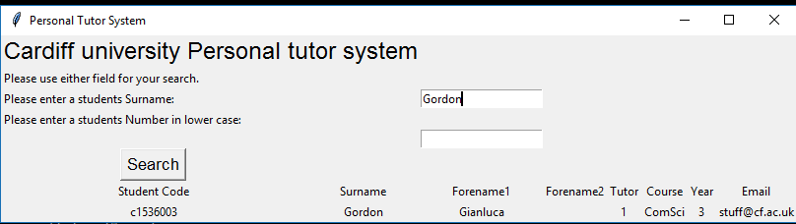
Related Tests: 5 and 6
Author: Gianluca Gordon |  |  | Checker: Alastair Morgan

Test Case Id: 5 |  | Test Purpose: Does program return results based on Student Number
Environment: Windows 7, Python 3.2.5, SQLite3
Preconditions: Window is open from launch hub, Surname field is empty
Test Case Steps:
Step No | Procedure |  |  | Response | Pass/Fail
1 | Enter Student Number into appropriate field. |  |  | N/A | PASS
2 | Click ‘Search’ button |  |  | Return results in tabulated format. | PASS
Comments: Text entry is not normalised so MUST be lower case.
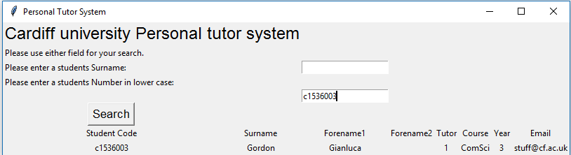

Related Tests: 4 and 6
Author: Gianluca Gordon |  |  | Checker: Alastair Morgan

Test Case Id: 6 |  | Test Purpose: Does program return an empty table for zero results
Environment: Windows 7, Python 3.2.5, SQLite3
Preconditions: Window is open from launch hub, both fields blank
Test Case Steps:
Step No | Procedure |  |  | Response | Pass/Fail
2 | Click ‘Search’ button |  |  | No results returned | PASS
Comments: No exception thrown, consider adding in later development.
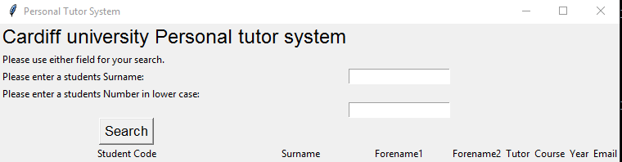

Related Tests: 4 and 5
Author: Gianluca Gordon |  |  | Checker: Nikola Kanev

